**Assignment -4**

Python Programming

|  |  |
| --- | --- |
| Assignment Date | 19 September 2022 |
| Student Name | Priyadharshini.S |
| Student Roll Number | 623519104033 |
| Maximum Marks | 2 Marks |

**Question-1:**

1.Create registration page in html with username, email and phone number and by using POST method display it in next html page.

**Question-2:**

2. Develop a flask program which should contain at least 5 packages used from pypi.org

**Note:-** Following application contains (Flask ,render_template,url_for,redirect,request)

So both Questions have same Answers

**Source Code:**

**App.py**

*from*tkinter.tix*import* Form

*from* flask *import*Flask ,render_template,url_for,redirect,request

app =Flask(__name__)

@*app*.*route*('/')

def*index*():

*return*render_template("index.html")

@*app*.*route*('/success/<name>/<phone>/<email>')

def*success*(name=None,phone=None,email=None):

*return*"<h1>Registered Successfully</h1><h2>Your Details Are:-</h2>  {}<br>{}<br>{}".format(name , phone ,email)

    # *'{} {} {}'.format(firstname, lastname, cellphone)*

@*app*.*route*("/login",methods=['POST','GET'])

def*login*():

*if*request.method=='POST':

        user =request.form['name']

        email =request.form['email']

        phone =request.form['phone']

*return*redirect(url_for("success",name= user ,phone= phone ,email= email ))

*else*:

        user =request.args.get("input_name")

*return*redirect(url_for("success",name=user))

*if* __name__ =='__main__':

    app.run(debug=True)

**index.html**

<!DOCTYPE*html*>

<html*lang*="en">

<head>

    <meta*charset*="UTF-8">

    <meta*http-equiv*="X-UA-Compatible"*content*="IE=edge">

    <meta*name*="viewport"*content*="width=device-width, initial-scale=1.0">

    <link*rel*="stylesheet"*href*="/static/style.css">

    <link*rel*="stylesheet"*href*="https://cdn.jsdelivr.net/npm/bootstrap@5.2.0/dist/css/bootstrap.min.css"

*integrity*="sha384-gH2yIJqKdNHPEq0n4Mqa/HGKIhSkIHeL5AyhkYV8i59U5AR6csBvApHHNl/vI1Bx"*crossorigin*="anonymous">

    <title>Registration page </title>

</head>

<body>

    <form*method*="post"*action*="login">

        <h1>REGISTRATION PAGE</h1>

        <div*class*="mb-3">

            <label*for*="name"*class*="form-label">Enter the name</label>

            <input*type*="text"*class*="form-control"*id*="name "*name*="name"*placeholder*="NAME">

        </div>

        <div*class*="mb-3">

            <label*for*="exampleInputEmail1"*class*="form-label">Email address</label>

            <input*type*="email"*class*="form-control"*name*="email"*id*="exampleInputEmail1"*placeholder*="EMAIL">

        </div>

        <div*class*="mb-3">

            <label*for*="phone"*class*="form-label">Enter the phone number</label>

            <input*type*="text"*class*="form-control"*name*="phone"*id*="phone"*placeholder*="PHONE NUMEBER">

        </div>

        <button*type*="submit"*class*="btnbtn-primary">Submit</button>

    </form>

</body>

</html>

**Style.css**

body{

    background-color: aqua!important;

    display: flex;

    flex-direction: column;

    align-items: center;

    justify-content: center;

}

form{

    display: flex;

    flex-direction: column;

    align-items: center;

    justify-content: center;

    background-color:#fff;

    width: 40%;

    height: 400px;

    border-radius: 50px;

    margin: 100px;

}

h2{

    font-size: large;

    font-weight:bolder;

}

input{

    width: 80%!important;

}

div{

    display: flex;

    align-items: center;

    justify-content: center;

    flex-direction: column;

    width: 90%;

}

**Output:-**

**Index Page:-**

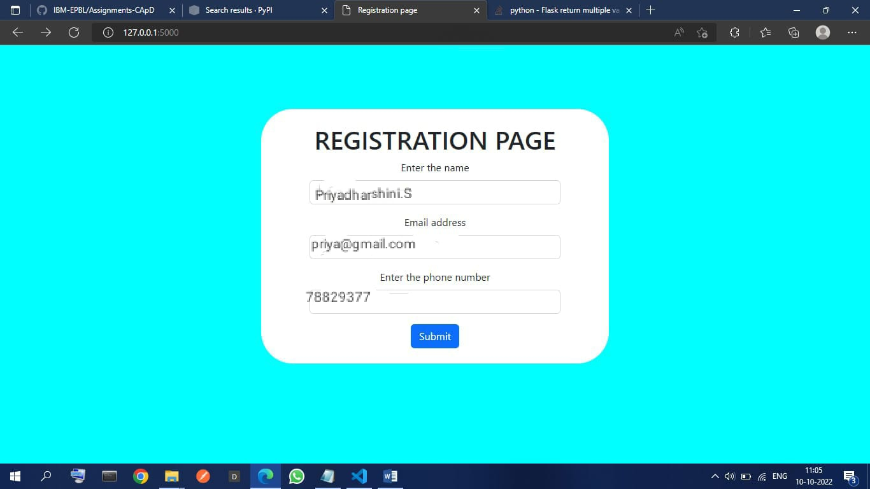

**Login successful page**

